***COMPLEX MAPPINGS***

****1.Converting a List Into a Grouped List:****

You may need to convert a flat list of items into a more structured list. For example, you may have list of all break_fast that have been completed. You may want to organize that list so that you can group the menu placed by each customer. This scenario typically occurs when you retrieve records from a relational database and the records must be structured differently.

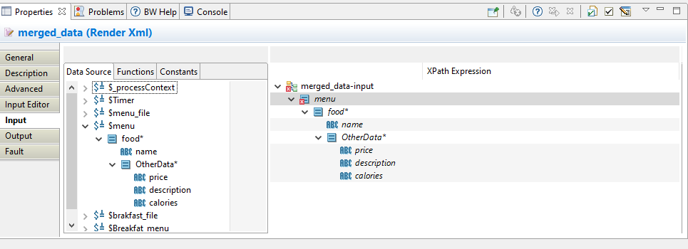

1. configured these schemas already in parsexml activities as below.

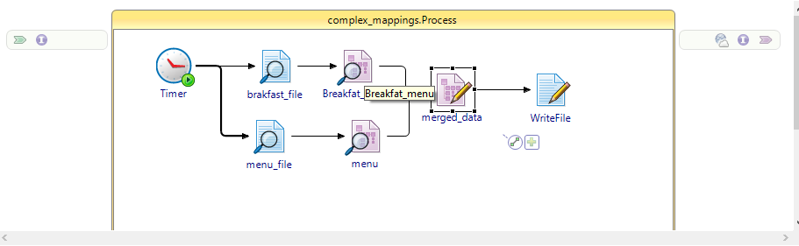

1. Break_fast xml schema as configured below.

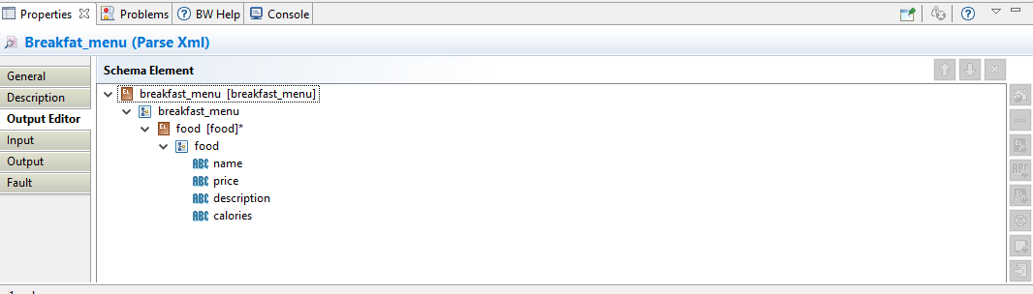

1. menu xml schema as configured below.

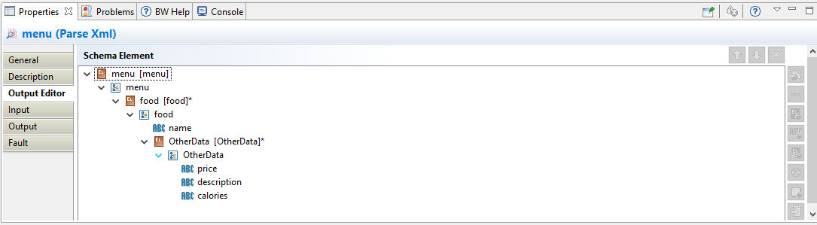

1. In break_fast read file taken data as below.

<breakfast_menu>

<food>

<name>Belgian Waffles</name>

<price>$5.95</price>

<description>Two of our famous Belgian Waffles with plenty of real maple syrup</description>

<calories>650</calories>

</food>

<food>

<name>Strawberry Belgian Waffles</name>

<price>$7.95</price>

<description>Light Belgian waffles covered with strawberries and whipped cream</description>

<calories>900</calories>

</food>

<food>

<name>Berry-Berry Belgian Waffles</name>

<price>$8.95</price>

<description>Light Belgian waffles covered with an assortment of fresh berries and whipped cream</description>

<calories>900</calories>

</food>

<food>

<name>French Toast</name>

<price>$4.50</price>

<description>Thick slices made from our homemade sourdough bread</description>

<calories>600</calories>

</food>

<food>

<name>Homestyle Breakfast</name>

<price>$6.95</price>

<description>Two eggs, bacon or sausage, toast, and our ever-popular hash browns</description>

<calories>950</calories>

</food>

</breakfast_menu>

1. in menu taken data as below.

<menu>

<food>

<name>Waffles</name>

<OtherData>

<price>$5.95</price>

<description>Two of our famous Belgian Waffles with plenty of real maple syrup</description>

<calories>650</calories>

</OtherData>

</food>

<food>

<name>Strawberry</name>

<OtherData>

<price>$7.95</price>

<description>Light Belgian waffles covered with strawberries and whipped cream</description>

<calories>900</calories>

</OtherData>

</food>

<food>

<name>Berry-Berry</name>

<OtherData>

<price>$8.95</price>

<description>Light Belgian waffles covered with an assortment of fresh berries and whipped cream</description>

<calories>900</calories>

</OtherData>

</food>

<food>

<name>French</name>

<OtherData>

<price>$4.50</price>

<description>Thick slices made from our homemade sourdough bread</description>

<calories>600</calories>

</OtherData>

</food>

<food>

<name>LITE Breakfast</name>

<OtherData>

<price>$6.95</price>

<description>Two eggs, bacon or sausage, toast, and our ever-popular hash browns</description>

<calories>950</calories>

</OtherData>

</food>

</menu>

***The following procedure describes how to map the flat list of orders into a list grouped by customer ID.***

1. Choose the repeating element in the Activity Input schema that holds the grouped data. In this example, that element is Orders. Right-click on this element and choose Surround with -> Surround with For-Each-Group… from the pop-up menu. This is a shortcut to create a For-Each-Group statement with the Orders element as a child element and a Grouping statement to contain the element you wish to group-by.

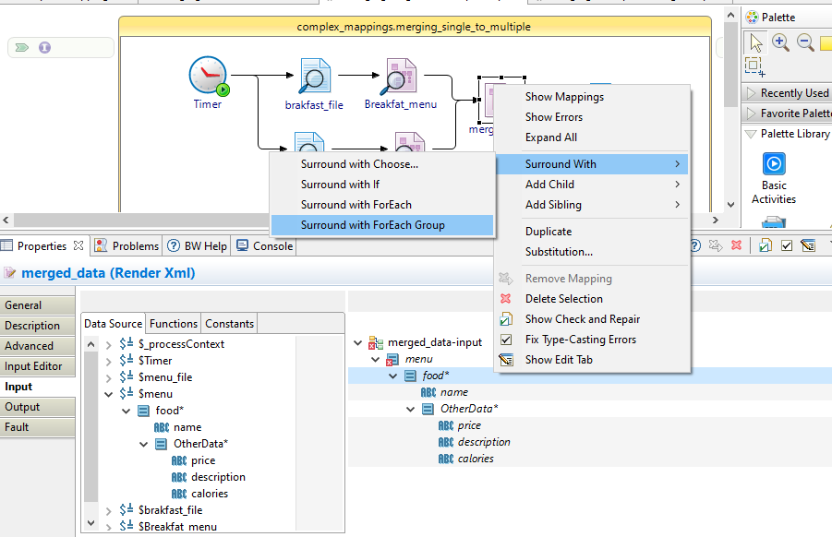

1. Drag the repeating element from the Process Data area to the For-Each-Group statement.
2. Drag the element you wish to group by from the Process Data area to the Grouping statement in the Activity Input area.

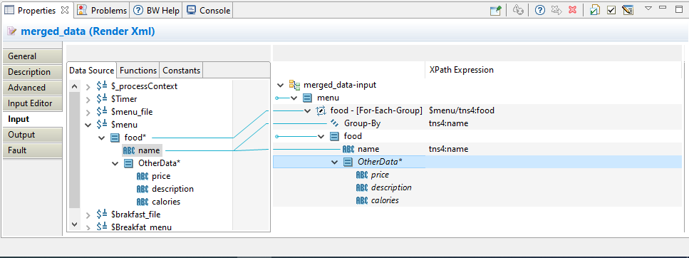

1. Choose the repeating element in the Activity Input schema that holds the details for each group. In this example, that element is Order. Right-click on this element and choose Surround with -> Surround with For-Each… from the pop-up menu. And next you will get current.position()

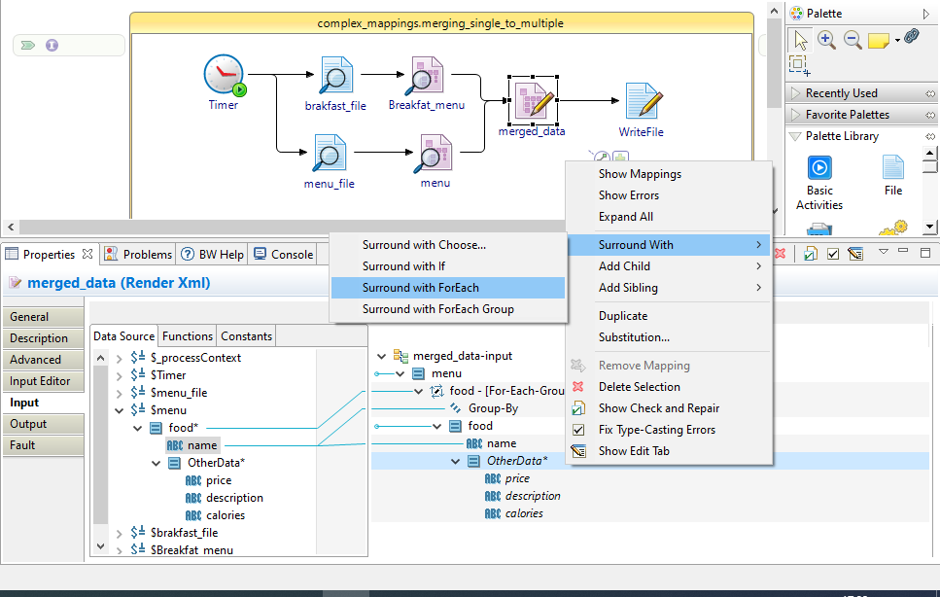

Map the all output elements to the render XML as below.

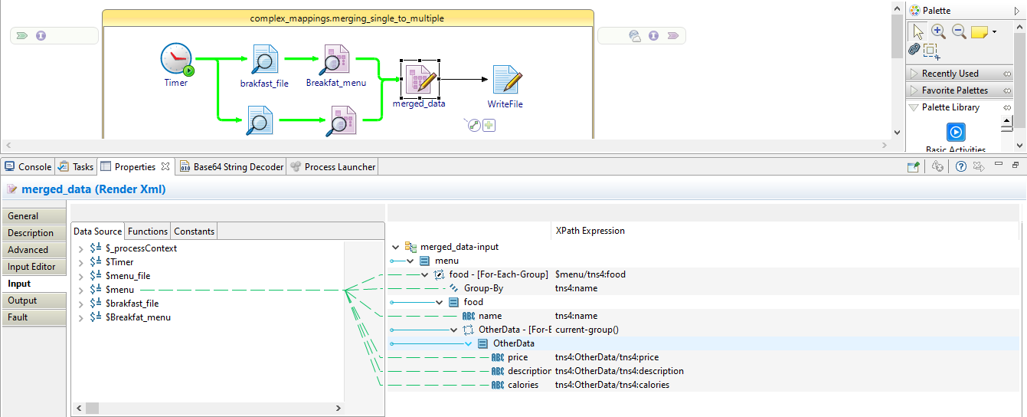

And debug the process you will get the group data in to the write file

Case1(success case):- for using of for each in second group output will be as below.

<?xml version="1.0" encoding="UTF-8"?>

<tns4:menu xmlns:tns5="http://www.example.org/merging_more_to_one1" xmlns:tns4="http://www.example.org/merging_more_to_one2">

<tns4:food>

<tns4:name>Waffles</tns4:name>

<tns4:OtherData>

<tns4:price>$5.95</tns4:price>

<tns4:description>Two of our famous Belgian Waffles with plenty of real maple syrup</tns4:description>

<tns4:calories>650</tns4:calories>

</tns4:OtherData>

</tns4:food>

<tns4:food>

<tns4:name>Strawberry</tns4:name>

<tns4:OtherData>

<tns4:price>$7.95</tns4:price>

<tns4:description>Light Belgian waffles covered with strawberries and whipped cream</tns4:description>

<tns4:calories>900</tns4:calories>

</tns4:OtherData>

</tns4:food>

<tns4:food>

<tns4:name>Berry-Berry</tns4:name>

<tns4:OtherData>

<tns4:price>$8.95</tns4:price>

<tns4:description>Light Belgian waffles covered with an assortment of fresh berries and whipped cream</tns4:description>

<tns4:calories>900</tns4:calories>

</tns4:OtherData>

</tns4:food>

<tns4:food>

<tns4:name>French</tns4:name>

<tns4:OtherData>

<tns4:price>$4.50</tns4:price>

<tns4:description>Thick slices made from our homemade sourdough bread</tns4:description>

<tns4:calories>600</tns4:calories>

</tns4:OtherData>

</tns4:food>

<tns4:food>

<tns4:name>LITE Breakfast</tns4:name>

<tns4:OtherData>

<tns4:price>$6.95</tns4:price>

<tns4:description>Two eggs, bacon or sausage, toast, and our ever-popular hash browns</tns4:description>

<tns4:calories>950</tns4:calories>

</tns4:OtherData>

</tns4:food>

</tns4:menu>

Case2(failure case):- not using for each in second group output will be as below.

<?xml version="1.0" encoding="UTF-8"?>

<tns4:menu xmlns:tns5="http://www.example.org/merging_more_to_one1" xmlns:tns4="http://www.example.org/merging_more_to_one2">

<tns4:food>

<tns4:name>Belgian Waffles</tns4:name>

<tns4:OtherData>

<tns4:price>$5.95</tns4:price>

<tns4:description>Two of our famous Belgian Waffles with plenty of real maple syrup</tns4:description>

<tns4:calories>650</tns4:calories>

</tns4:OtherData>

</tns4:food>

<tns4:food>

<tns4:name>Strawberry Belgian Waffles</tns4:name>

<tns4:OtherData>

<tns4:price>$7.95</tns4:price>

<tns4:description>Light Belgian waffles covered with strawberries and whipped cream</tns4:description>

<tns4:calories>900</tns4:calories>

</tns4:OtherData>

</tns4:food>

<tns4:food>

<tns4:name>Berry-Berry Belgian Waffles</tns4:name>

<tns4:OtherData>

<tns4:price>$8.95</tns4:price>

<tns4:description>Light Belgian waffles covered with an assortment of fresh berries and whipped cream</tns4:description>

<tns4:calories>900</tns4:calories>

</tns4:OtherData>

</tns4:food>

<tns4:food>

<tns4:name>French Toast</tns4:name>

<tns4:OtherData>

<tns4:price>$4.50</tns4:price>

<tns4:description>Thick slices made from our homemade sourdough bread</tns4:description>

<tns4:calories>600</tns4:calories>

</tns4:OtherData>

</tns4:food>

<tns4:food>

<tns4:name>Homestyle Breakfast</tns4:name>

<tns4:OtherData>

<tns4:price>$6.95</tns4:price>

<tns4:description>Two eggs, bacon or sausage, toast, and our ever-popular hash browns</tns4:description>

<tns4:calories>950</tns4:calories>

</tns4:OtherData>

</tns4:food>

</tns4:menu>